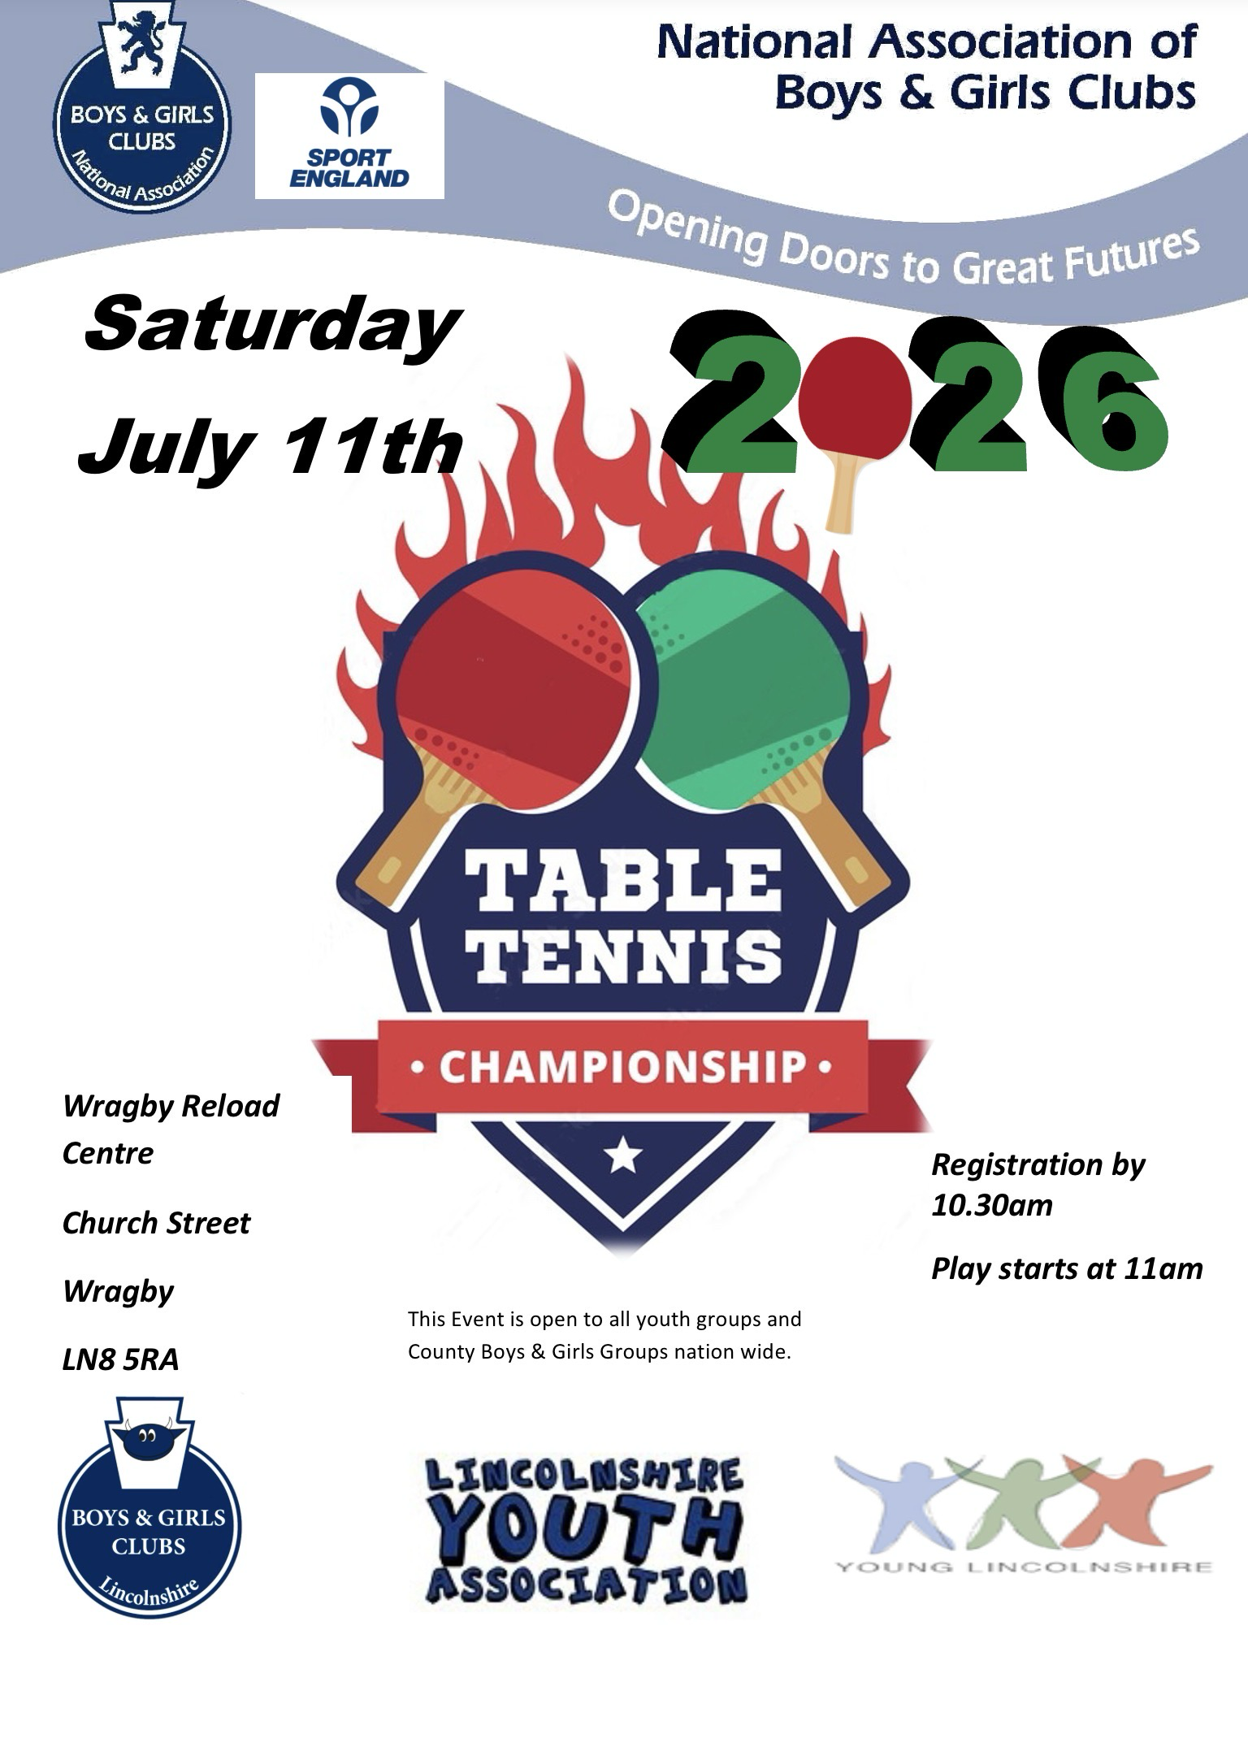
Joining Instructions

Thank you for your interest in NABGC’s 2025 UK Table Tennis Championship, with entry via your club, county or region.

With many of our participants being champions in their own right, we are going to have a fantastic day of table tennis and meeting many other young people and volunteers from around the UK.

We look forward to seeing you at the event and hope the following answers any questions you may have. If you have any problems, issues or withdrawals from the event, please contact me ASAP on the enclosed numbers.

Venue Wragby Reload Centre, Church Street Wragby, LN8 5RA

Date Saturday 12th July 2025

Start time Participants must register at the Reception Desk by 10.30am.
The finals are scheduled to start at 11.00am.

Refreshments There is a refreshments available serving hot and cold food within the Youth Centre, all at reasonable prices.

Age groups U12 over 10 and under 12 as of 1.9.2025
U14 over 12 and under 14 as of 1.9.2025
U16 over 14 and under 16 as of 1.9.2025
U19 over 16 and under 19 as of 1.9.2025
All inclusive group 11-25 as of 1.9.2025

Format Each age group will be arranged as to ensure that participants have a full day’s play.

The format will be a series of round robin group games, followed by a knockout
phase into the finals or a round robin league basis. The format will depend on the
entries in each event. This will be advised to each group prior to the start of their

event.

Telephone Organiser’s number: Charles Shaw 07818434346 / 01522 569776
James Walker 07595602601

Return Address: YDA Chamber, 1A-2A Beaumont Fee, Lincoln, LN1 1UU

Clothing Please dress appropriately for a UK sports final – trainers, sports clothing but not
white and not jeans and t-shirts.
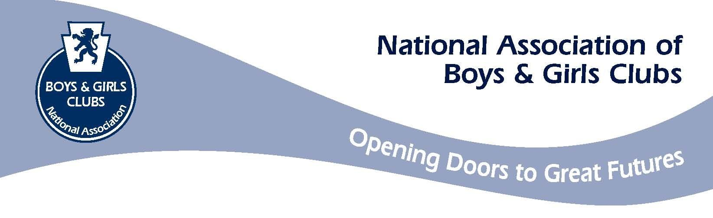

Booking Form

Welcome

Thank you for expressing an interest in taking part in NABGC’s UK Table Tennis Championship.

The following pages give you the information you need to make a decision to enter, but if you require further clarification on any points please do not hesitate to get in touch on the details below.

Where Wragby Reload Centre, Church Street Wragby, LN8 5RA

When Saturday 11th July 2026
The finals are scheduled to start at 11.00am, with registration by 10.30am.

Cost Direct entry: £10.00 per person Advanced and £12 on the door per entry
Qualification through area events: £10.00

All clubs will be required to register their entries.

Age groups U12, U14, U16, U19 as of 1st Sept 2025. Male and female.
Plus an all inclusive group 11-25

Competition There will be separate competitions for males and females, with two com-

petitions in each age group if sufficient entries are received by the closing
date:

1. The main championships, where regional winners will be seeded.
2. A plate competition, for players who do not qualify in the initial rounds of

the main competition.

To take part please complete and send the form(s) below, along with the cheque for payment (made payable to “Boys and Girls Club”) to your county organiser who will countersign and forward on to us.

Please return entries to us by Tuesday July 7th 2025 - Late Entries cannot be guaranteed.

UK Table Tennis Championship 2025

Entry form

Please use one form per person and photocopy if necessary.

Name of participant

Date of birth

Name of club

Address for correspondence

Club email address

Telephone number (day) (evening)

I wish to enter in the following competition (please circle):

 | U12 Boys | U14 Boys |  | U16 Boys | U19 Boys | All inclusive  11-25
 | U12 Girls | U14 Girls |  | U16 Girls | U19 Girls
Fee enclosed or bank transfer  made payable to must be paid before the event!  Wragby Youth Centre Trust  Sort code 40-28-20  Account Number 72466273 |  |  | ☐(£10 per entry)

I agree to abide by the rules of the event.

Signed

Position

Please send this to your county organisation for endorsement to forward to NABGC no later than Tuesday July 7th

Signature of county organiser …………………………………………. Date :

UK Table Tennis Championship 2025

County Results form (MALE)

County/ Country
Durham

NABGC counties and countries can enter up to a maximum of three players per age group.

Players | Club | Date of Birth
U12s
1.
2.
U14s
1.
2.
3.
U16s
1.
2.
U19s
1.
2.
3.

UK Table Tennis Championship 2025

County Results form (FEMALE)

County/ Country
Durham………………………………………………………………………………

NABGC counties and countries can enter up to a maximum of three players per age group.

Players | Club | Date of Birth
U12s
1.
2.
3.
U14s
1.
2.
3.
U16s
1.
2.
3.
U19s
1.
2.
3.

