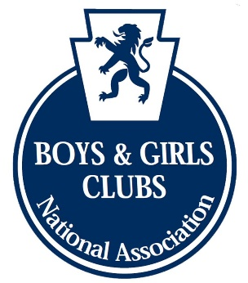

NABGC 5-a-side TOURNAMENT RULES

- Each team is allowed 8 players with only 5 players permitted on a pitch at any one time, with 3 substitutes on the sidelines.
- These squad members MUST REMAIN THE SAME THROUGHOUT THE TOURNAMENT.
- Each team will consist of 4 outfield players and a goalkeeper.
- All team players must be attired in strips, footwear and shin pads.
- No jewellery is permitted.
- Each game shall commence with a kick-off.
- After a goal, play shall commence with a kick-off.
- should the ball be played over the height of the boards then it is a free kick from where the ball was played over to the opposition,
- All players are allowed to enter the goal area.
- If goalkeepers leave their goal area, a penalty shall be awarded.
- A goal may be scored from any point outside the goal area within the field of play, unless a defender scores an own goal.
- Pass backs to the goalkeeper: A goalkeeper is not permitted to pick up the ball following a back pass from a team-mate. Punishment will result in a direct free kick 2 yards outside the goal area, nearest to where the infringement occurred.
- No Metal Blades/ Studs are permitted to be worn on the pitches, only moulded boots/ trainers are allowed
- Teams are permitted to change goalkeepers during the game, but only when play has been stopped and the referee informed.
- A substitution may be made at any time and more than once during the game but must be authorised by the referee.
- If any teams are reduced to 3 men due to misconduct the game shall end. The game shall then be awarded to the opposition 3-0.
- All free kicks will be direct.
- Goals scored from either penalty area will be disallowed
- Penalty kicks shall be taken with a one-step rule, one motion Rule.
- Sliding tackles are banned with punishment being a free-kick.
- Violent conduct on or off the pitch will lead to immediate suspension of the individual(s) concerned for the duration of the tournament. Powerleague Soccer Dome reserves the right to ban any individuals or teams from all future participation in the leagues or tournaments.

PLEASE ALSO BE AWARE
Persistent unsporting behaviour by players or team officials will result in the team being removed from the competition.
Also, persistent unsporting behaviour by supporters will result in the team being removed from the competition.
Continued abuse of match officials will result in the team being removed from the competition.

